**DAILY ONLINE ACTIVITIES SUMMARY**

|  |  |  |  |  |  |  |  |
| --- | --- | --- | --- | --- | --- | --- | --- |
| **Date:** | **18-05-2020** | | | | **Name:** | **K Manasa** | |
| **Sem & Sec** | **8th 'A'** | | | | **USN:** | **4AL6CS043** | |
| **Online Test Summary** | | | | | | | |
| **Subject** | | **System Modelling and Simulation** | | | | | |
| **Max. Marks** | | **60** | | **Score** | | **32** | |
| **Certification Course Summary** | | | | | | | |
| **Course** | **Python for Machine learning** | | | | | | |
| **Certificate Provider** | | | **Great learning** | **Duration** | | | **1hrs** |
| **Coding Challenges** | | | | | | | |
| **Problem Statement:Finding a frequency of each character in a string and to point the even and odd for series** | | | | | | | |
| **Status:Solved** | | | | | | | |
| **Uploaded the report in Github** | | | | **Yes** | | | |
| **If yes Repository name** | | | | **Manasa** | | | |
| **Uploaded the report in slack** | | | | **Yes** | | | |

Online Test Details: (Attach the snapshot and briefly write the report for the same)

Certification Course Details: (Attach the snapshot and briefly write the report for the same)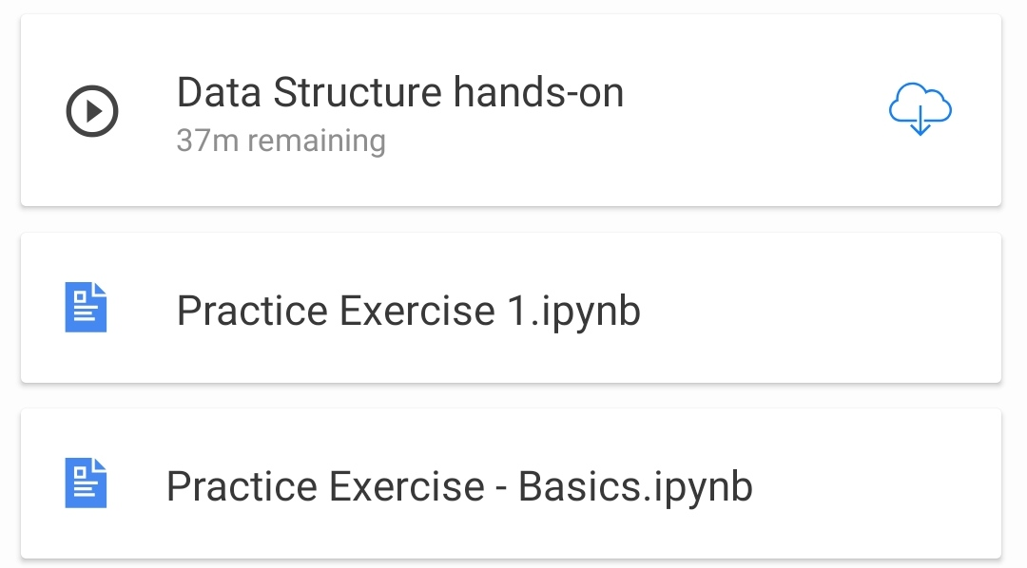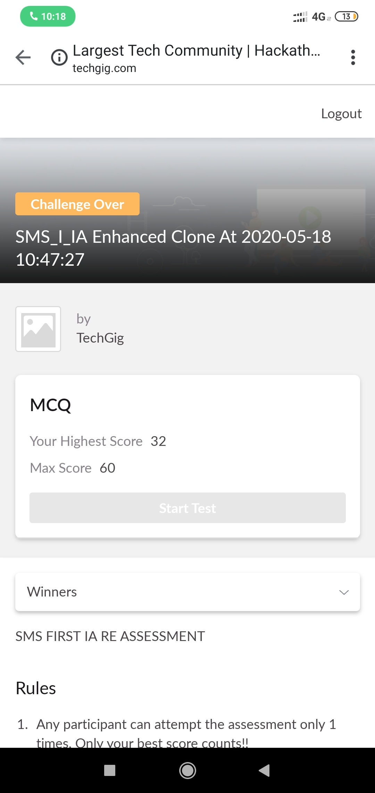

Coding Challenges Details: (Attach the snapshot and briefly write the report for the same)



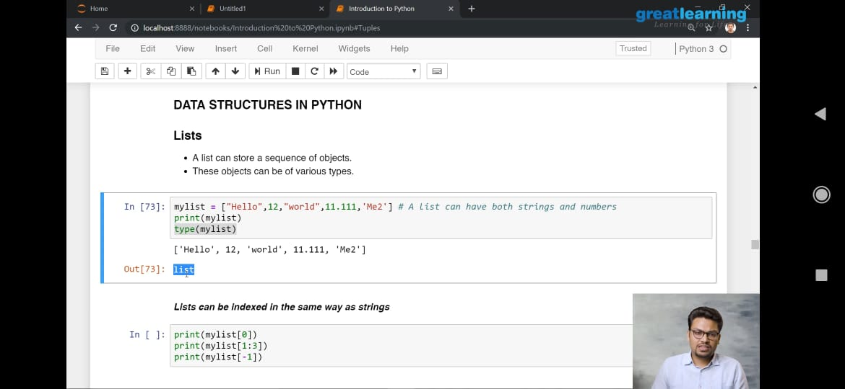

import java.util.Scanner;

public class Main

{

public static void main(String[] args) {

int i;

String str;

int count[] = new int[256];

Scanner s = new Scanner(System.in);

System.out.print("Enter a String : ");

str=s.nextLine();

for (i = 0; i < str.length(); i++) {

count[(int) str.charAt(i)]++;

}

for (i = 0; i < 256; i++) {

if (count[i] != 0) {

System.out.println( (char) i + " : " + count[i]);

}

}

}

}